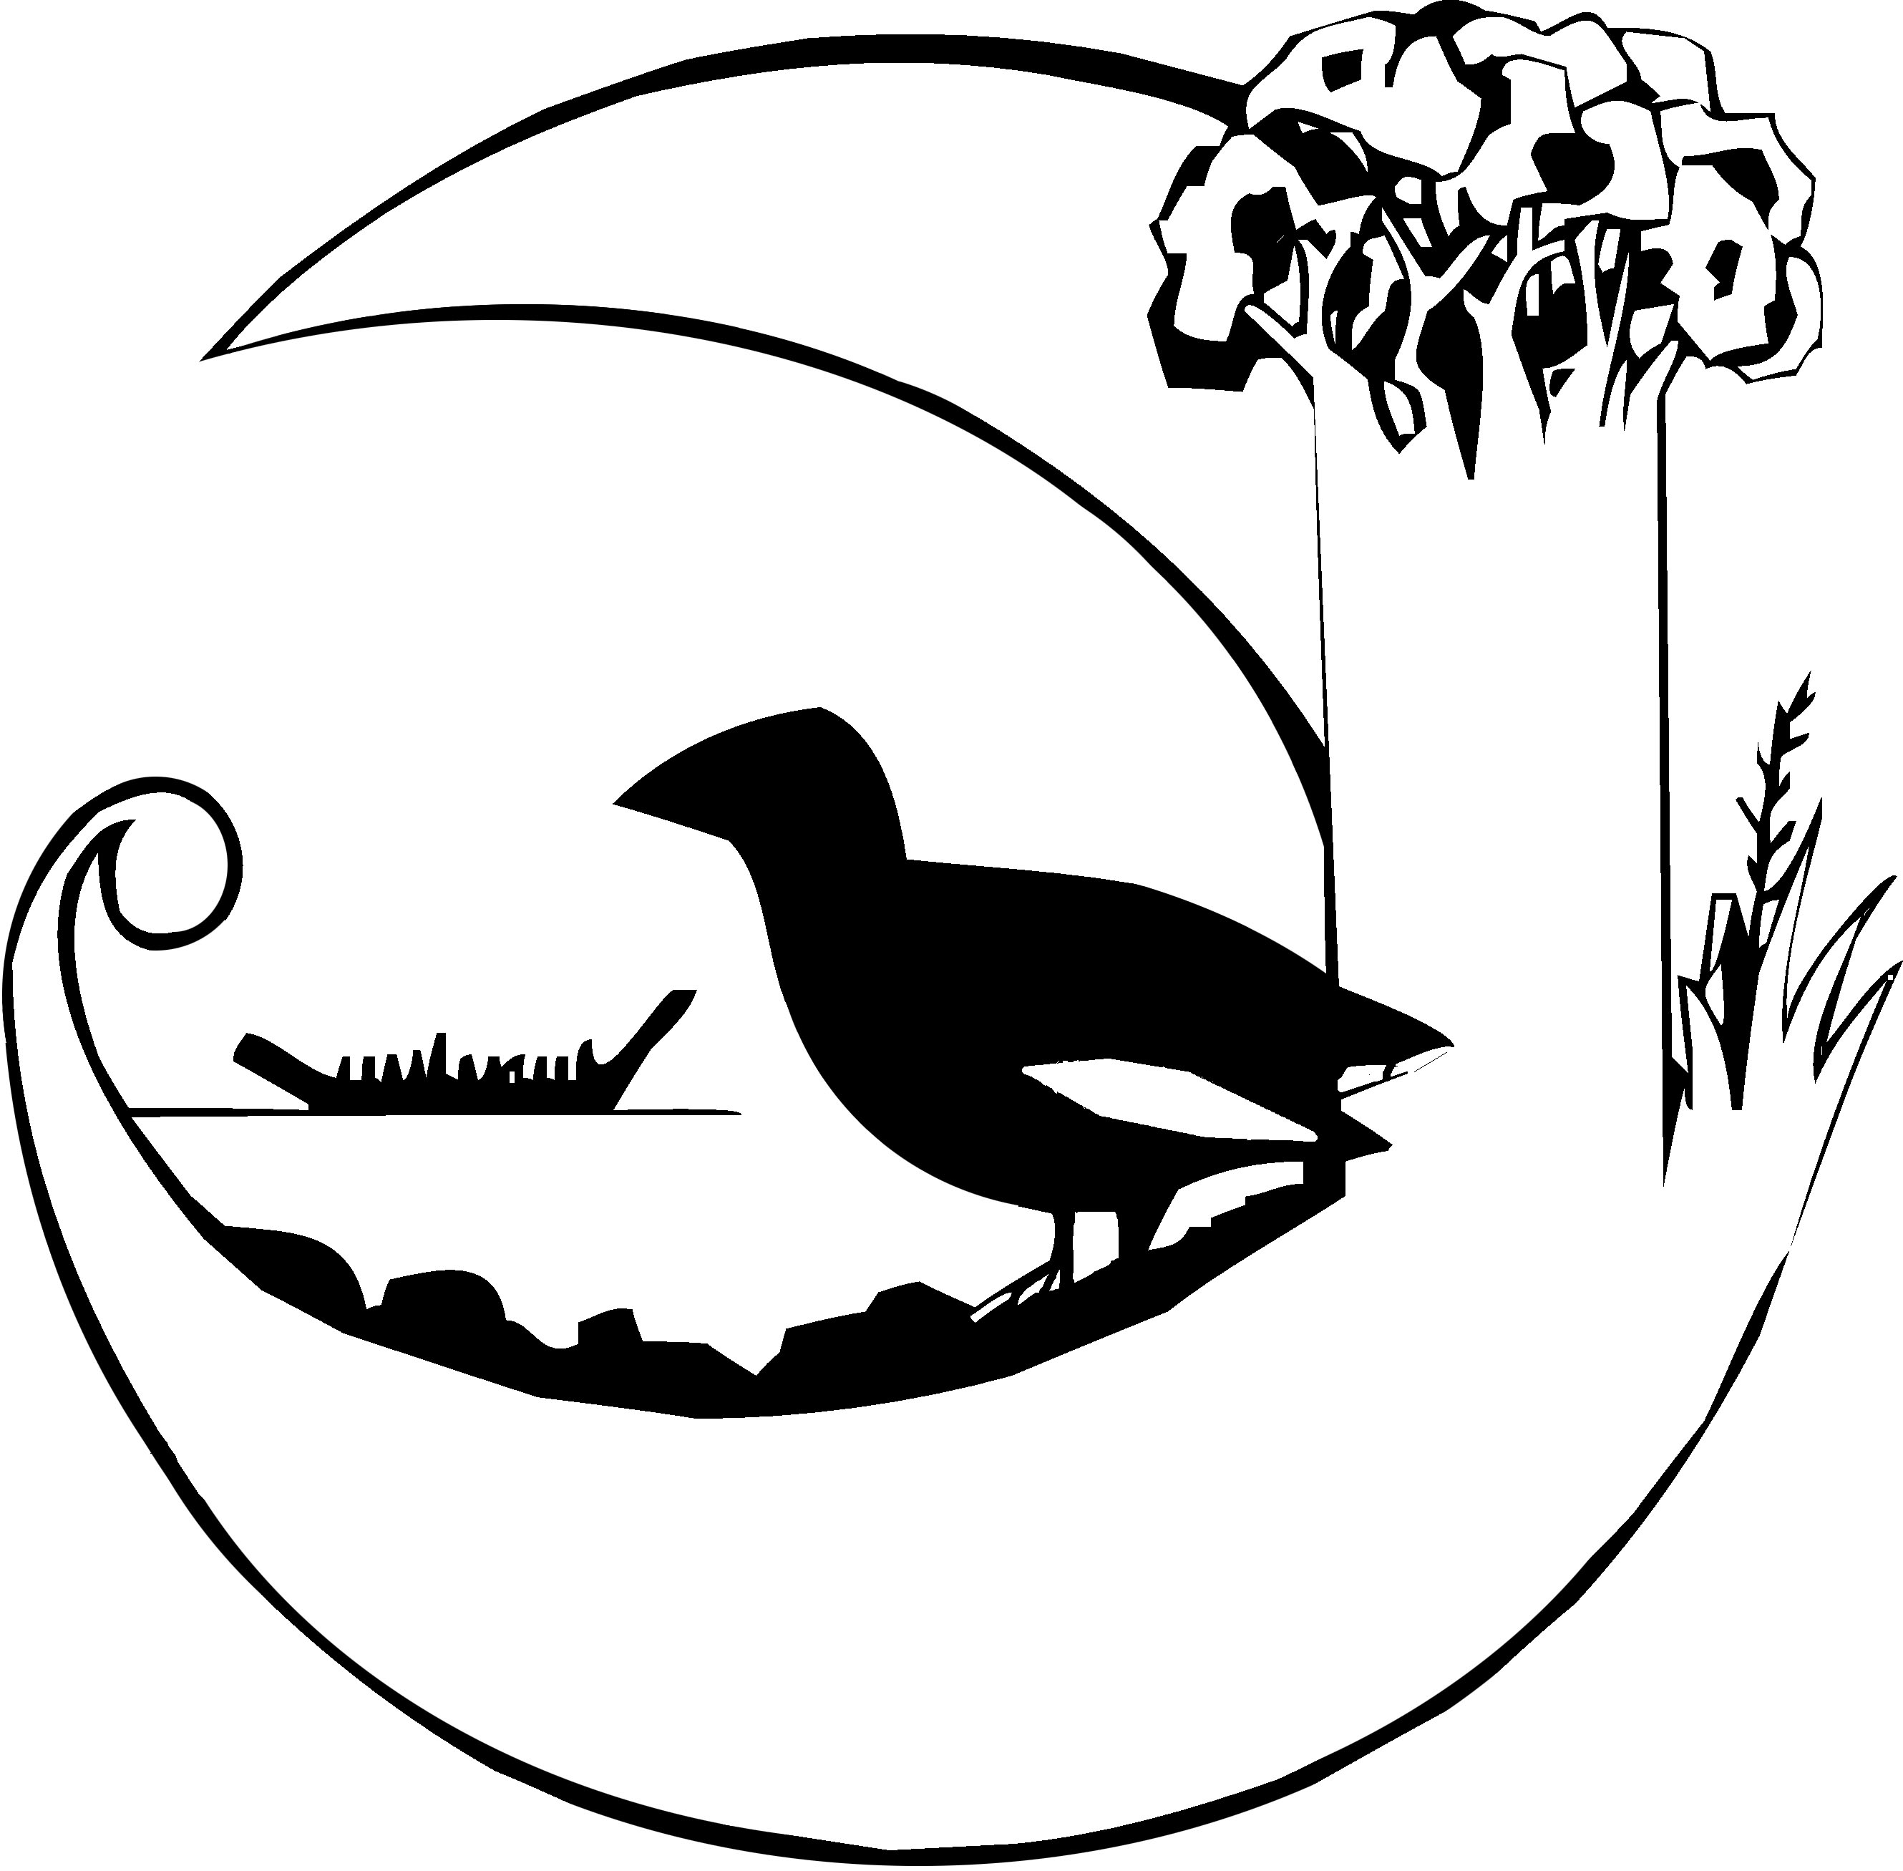2024 School Spelling Competition.

This year’s spelling competition takes place in Week 2 of next term on Thursday the 1st August. There are three categories – Seniors for Years 5-6, Middle for Years 3 and 4, and Juniors for Years 1-2. The winners of each category win the school spelling trophy which will be awarded at the end of year prize giving.

Below are some of the words that will be used in the Junior competition – learning as many of these as possible will help during the event. It is not expected that children will learn all of these words but the more they learn the greater chance they have of winning! The finals allow for words other than those in this list so learning spelling skills helps!

The children will hear the word and must spell it out loud so it is best to practice that way.
Good luck!

I | Mum | up | can | went | am
Dad | my | to | in | A | like
go | and | for | is | see | said
me | at | the | on | look | going
we | got | you | she | play | are
away | day | little | as | but | want
today | all | call | be | car | back
after | boy | come | cousin | girl | down
ask | came | let | It | jam | dog
soon | here | sit | so | of | hot
cup | van | lost | plan | mud | beg
big | are | do | who | cat | sun
food | car | art | run | hit | cry
eye | but | see | come | bring | good
love | ran | two | ball | bat | our
try | book | tree | rain | bee | hat
coat | chop | fire | fight | friend | done
any | great | sure | desk | shoes | football
hide | never | moon | hole | corner | next
space | wrong | hurry | climb | smell | below
flower | star | bike | hand | Monday | trip
cut | moon | bang | planet | sure | like

