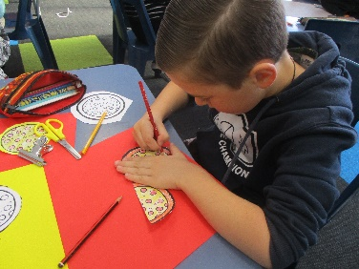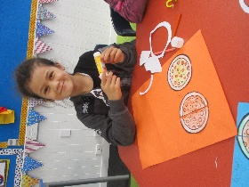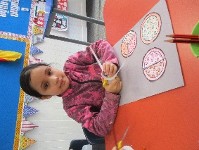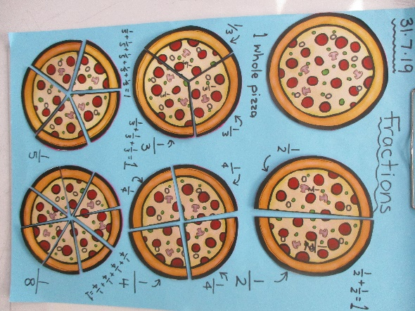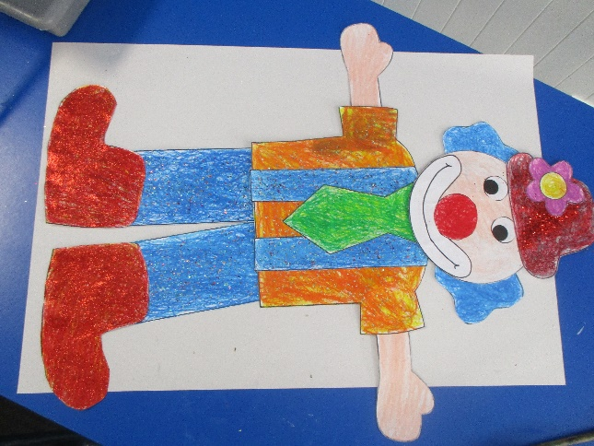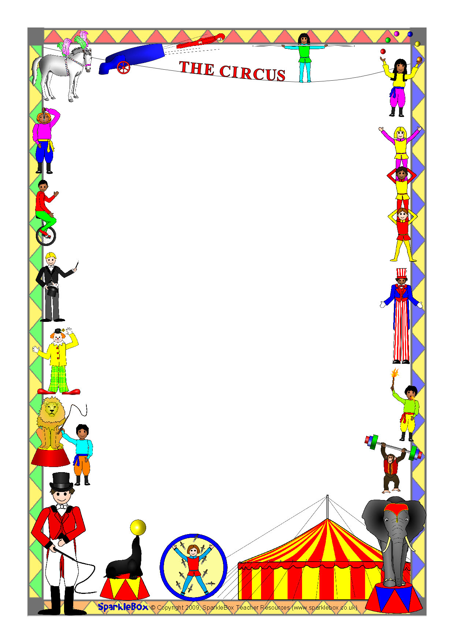

For maths, we have been exploring fractions. We know all about the denominator of a fraction tells us how many the whole object is split into. We have also been learning how to write fraction symbols.

Welcome to Room 4’s newsletter for Week 2, Term 3. Below is a sneak preview of our first piece of artwork for this terms Art Exhibition. We have been clowning around with art and learning to juggle.

A couple of children have already learnt to juggle with two juggling balls with ONE Hand!

Next week we will be starting to juggle with scarves, and beginning to plan our circus show… watch this space.

Room 4 – Newsletter – Week 2